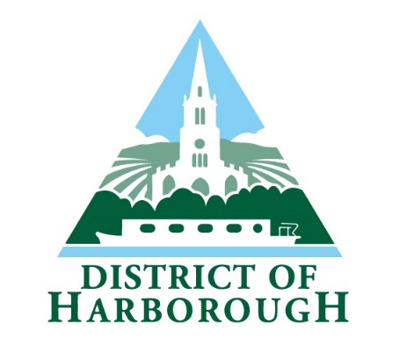

Community Governance Review
Mowsley Parish

At its meeting of 24 February 2025 Harborough District Council considered a report outlining the response to the consultation on whether to establish a Parish Council for Mowsley. Six responses to the consultation were received, four in support and two against. These were shared with Council. Given the small number of responses and the minor variance between those in favour and those against, the Council decided that it was not clear that the community was in support of the establishment of a Parish Council or that, if one was established, it would be able to operate effectively. Therefore Council agreed not to establish a Parish Council for Mowsley at this stage. Further discussions will be held in the Parish to decide how best to proceed.

