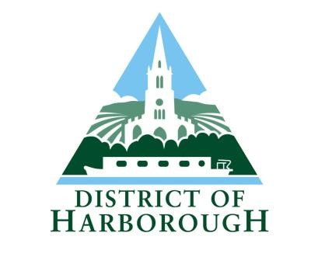
Harborough District Council
Performance Management Framework

1. CONTEXT

Introduction

Performance management is essential to support Harborough District Council to realise our Vision and deliver our Priorities.

Our Vision

Working with our communities, we will build a future for the people of Harborough District that gives them the best life chances and opportunities.

Our Priorities

The Council’s priorities are:

- Community Leadership to create a sense of pride in our place.
- Promoting health and wellbeing and encouraging healthy life choices.
- Creating a sustainable environment to protect future generations.
- Supporting businesses and residents to deliver a prosperous local economy.

Defining Performance Management

Performance management can be defined as:

“an integrated approach that helps organisations to define and execute their strategy and to measure and monitor performance in order to help decision makers
improve the organisation’s performance”. The Performance Pulse, CIPFA 2011 Harborough District Council’s Approach to Performance Management

The Performance Management Framework (PMF) sets out the overall high-level approach Harborough District Council will take to performance management. It will help staff and Members to:

- Be clear about what we are trying to achieve
- Set out exactly what we are going to achieve
- Monitor whether or not we are achieving it
- Continually challenge and seek to improve service delivery
- Be accountable to the communities we serve
- Report on how well we are doing to both internal and external audiences
- Be consistent in the way performance is managed

The PMF provides the framework for consistency in the way performance is managed and joined-up across every service in the Council – a ‘one council’ approach. A coherent and consistently-applied PMF promotes efficiency and focus on critical areas of service delivery at a time when financial pressures on the Council are as challenging as they have ever been.

Councillors have a key role to play in supporting the PMF through scrutiny of performance and effective challenge to service delivery and policy. In turn, the PMF supports Councillors to ensure they are provided with the right information that allows them to make informed decisions on service delivery and policies.

The Council is no longer subjected to statutory external assessment of its overall performance. Local authorities now have greater responsibility for their own regulation and improvement. It is therefore imperative that the Council has a transparent system of selfregulation and accountability, which involves our community in more of our decision making and service provision choices.

Related Frameworks, Strategies and Policies

The PMF is intrinsically linked to a number of other frameworks, strategies and policies that apply across Harborough District Council, including:

- Corporate Plan
- Team Plans
- Competency Framework
- Risk and Opportunity Management Framework
- Medium Term Financial Strategy
- Communications Strategy
- Customer Services Strategy
- Workforce Strategy

2. OUR APPROACH TO PERFORMANCE MANAGEMENT

The Performance Management Cycle

Performance management at Harborough District Council is based around a continuous and cyclical process made up of four stages: PLAN → DO → REVIEW→ REVISE.

The figure below illustrates the four stages of the PMF and how they relate to each other:

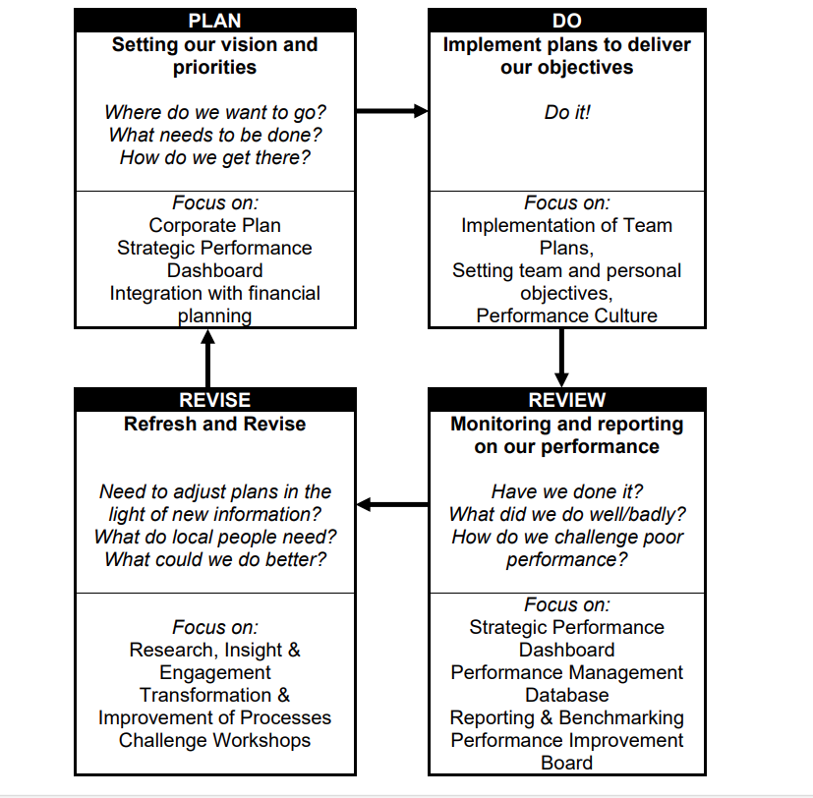

The following diagram shows how the ‘Plan-Do-Review-Revise Model’ fits together at the
Council. It also shows the ‘golden thread’ which links the Council’s Corporate Plan directly to individual employee objectives set during Appraisals.
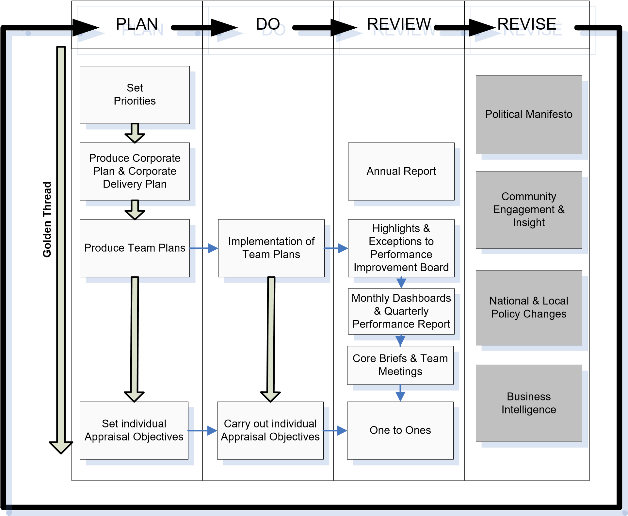

STAGE 1: PLAN – Setting our vision and priorities

Our Priorities

The vision for Harborough District Council is set out in our Corporate Plan and is influenced by the ruling political group’s manifesto, changes to national and local policy, business intelligence and customer engagement and insight.

Our Corporate Plan

Our Corporate Plan is outward facing. This document:

- outlines the key priorities for the council and how we intend to achieve them.
- takes account of government policy directives.
- determines the shape of our Team Plans.
- provides a framework against which each member of staff’s performance can be appraised.

The Corporate Plan is supported by the Medium-Term Financial Strategy. This sets out how the Council will manage its overall budget to deliver its objectives and deal with any funding constraints.

Our Corporate Delivery Plan

In previous years the Corporate Plan and Corporate Delivery Plan were two separate documents. For the 2022/23 year, and beyond, the documents have been combined into one document known as the ‘Corporate Plan’.

A series of headline performance measures will be developed to monitor the achievement of our Critical Outcomes, and ultimately our priorities. A number of these are measured through the Strategic Performance Dashboard which is produced on a monthly basis and appended to Quarterly Performance Reports.

Delivery of corporate objectives is monitored throughout the year through the Council’s Performance Management Database and through regular meetings with portfolio holders. Performance Reports are produced on a quarterly basis for submission to the Cabinet and Scrutiny.

The Corporate Plan is refreshed annually to ensure it remains appropriate to delivering our priorities.

Team Plans

Team Plans are operational, working documents. These contain details of the activities that each team will be undertaking to support the Corporate Plan, including milestones, outcomes and benefits. They also detail the operational activities that each team will be delivering.

Actions from Team Plans are monitored through the Council’s Performance Management Database and through regular one-to-one meetings.

Individual Objectives

Each member of staff agrees a set of personal objectives to achieve at their annual Performance Appraisal. These demonstrate how each employee contributes both to their team and the organisation as a whole, and therefore how each individual has a role in achieving our priorities. Performance Appraisals are reviewed at the half-year position.

STAGE 2: DO – Implement plans to deliver our objectives

Each team delivers Key Activities and operational actions as set out in their Team Plans. These plans are live documents and are continually kept under review to take account of any ongoing issues such as political changes at central or local level, changes to policy, and community engagement and insight.

Performance Culture

Developing a strong council-wide performance management culture is pivotal to Harborough District Council’s commitment to deliver good quality, efficient services.

In order for an effective performance management culture to flow through the organisation, there should be strong leadership and commitment at the highest level from Members, the Corporate Management Team and the Senior Management Team which should set a clear example for others to follow.

Everyone at the Council has responsibility for effective performance management and this is recognised in the Harborough District Council Competency Framework, specifically through the key competency of ‘improving performance and teams’, against which each employee is assessed.

The Competency Framework outlines what is expected from each tier in the organisation in terms of performance management and the skills and behaviours needed to achieve these levels, including recognising achievements and performance against planned objectives, providing quality feedback, striving towards service improvement and embedding a performance culture.

Training

Training and retaining a highly-skilled and motivated workforce will enable the Council to deliver high quality, responsive, efficient and valued services.

Individual training and development needs are identified primarily through Performance
Appraisals. Internal audit and service reviews may also identify training gaps for staff and Members.

Training is delivered through a variety of methods including presentations, workshops and the online Learning Pool.
STAGE 3: REVIEW – Monitoring and reporting on our performance

The Pentana Performance Management System

In order to ensure performance is managed consistently and effectively across the authority, the Council has developed a performance management system on Pentana which allows each team to collect, report, analyse and manage performance information efficiently.

This information is used to collate and report performance on a monthly and quarterly basis.

Both Members and Officers are encouraged to make use of Pentana as a dynamic performance tool.

Performance Review & Challenge

It is not enough to simply monitor and report performance. Performance information must be reviewed and challenged to drive improvement, realise efficiencies and deliver effective services.

There are processes in place at all levels of the organisation to ensure that effective review and challenge is undertaken.

Level | Details
Individual | Annual and mid-year Performance Appraisal and one-to-one meetings are used to review of progress against individual objectives.
Teams | Team Meetings and Core Briefing sessions are used to review progress against Team Plans.
Performance  Improvement  Board | This group meets monthly to review performance, particularly  ‘highlights’ of good performance and ‘exceptions’ of underperformance. Outcomes are reported to the Corporate Management Team as appropriate and feed into the regular Performance Reports.
Corporate  Management  Team (CMT) | Review of every Quarterly Performance Report, including the Strategic Performance Dashboard, and review of performance exceptions as highlighted through the Performance Improvement Board.
Councillors | The Cabinet considers performance against Key Activities at the end of each Quarter via Performance Reports, the Strategic Performance Dashboard and through regular progress reviews with managers. Scrutiny receives the same quarterly performance reports that the Cabinet does.

In addition to these mechanisms, there are other forms of review that may focus on particular service areas at certain times:

What? | Details
Customer Insight and Engagement | Engagement with our residents can provide valuable feedback to help inform decisions and improve our services. This could include use of focus groups, interaction with local community groups and carrying out consultation and surveys.
Complaints and Compliments | The public are encouraged to provide feedback to us on the services we provide; whether it be a compliment, comment, suggestion or a complaint. This information is essential to help us know what we are doing right and where we are getting things wrong.
Self Assessment/ Peer Challenge | Service teams can carry out a variety of exercises and tests to evaluate their own performance and/or involve peers from other organisations to do this.
Audit | The central government inspection regime is much reduced but we are still required to undertake a certain amount of audit.

Transparency

Access to regular reports on how the Council is performing is essential for our residents to see how we are performing. Quarterly Performance Reports are available and are in the public domain.

Data Quality

To ensure robustness and data quality, all reported performance information must adhere to the Council’s Data Quality Strategy. Data Quality challenges are undertaken as appropriate which require officers to provide supporting evidence for performance figures.

Performance Benchmarking

Relative comparison with other councils ensures we understand the wider context of service delivery by seeing how similar organisations are performing and allowing us to learn from best practice.

STAGE 4: REVISE – Refresh and Revise

Our Corporate Plan is refreshed each year.

Our Corporate Delivery Plan and Team Plans are also revised on an annual basis to ensure that we are delivering the right services, in the right ways, to the right people. This includes a review of priorities and Critical Outcomes, and a full revision of the Key Activities and performance measures that deliver these, and the risks to their achievement.

Research is an integral part of this process to keep abreast of evolving government policy and emerging issues at both national and local level, as well as our changing community profile.

Customer feedback in the form of compliments, comments, suggestions and complaints should be reviewed regularly as they provide valuable information on what we are doing well and how we could improve our services. Receiving and acting upon customer feedback in an appropriate way should be an ongoing process within each team in the Council.

PMF Review

The PMF itself will be subject to review on a two-yearly cycle to ensure it remains appropriate to Council needs and requirements.

3. ROLES & RESPONSIBILITIES

Everyone at Harborough District Council plays a part in the Performance Management Framework. The diagram below illustrates how each individual contributes:

