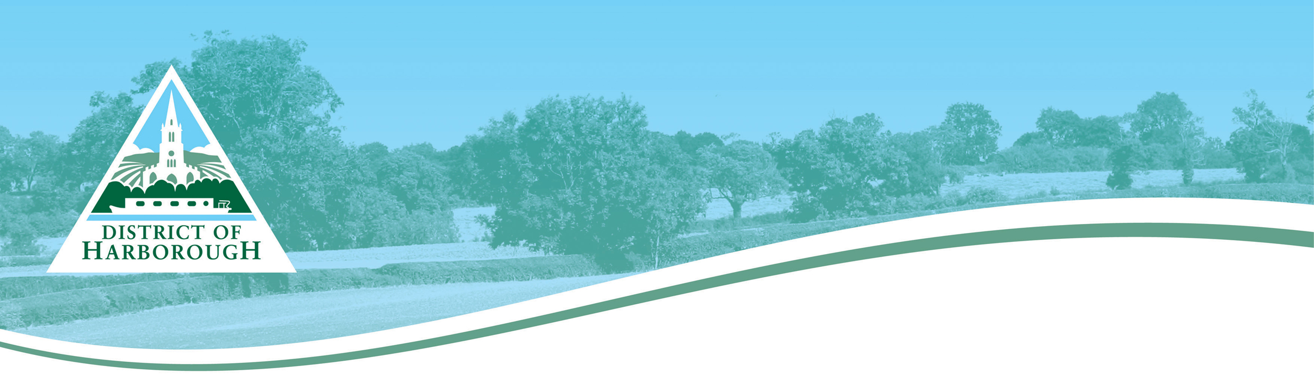
Application for a new street name and numbering of properties.
Developments of more than 5 properties.

1. Applicant Details

Name of contact
Company name
Contact address

Telephone number - Land
Telephone number – Mobile
Fax number
Email address

How would you prefer to be contacted?

2. Application Details
Planning Application Ref.
Development Address

Category for Street Naming

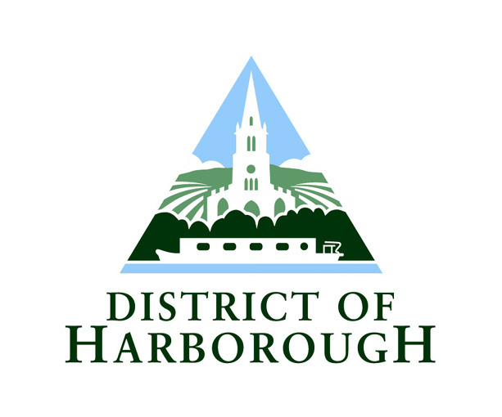
3. New Street Names
Please provide the name of the street(s) that you would prefer using the guidance notes for assistance. If you require more than one street named, please add using extra pages.
See Street naming and numbering - Further guidance on Street Naming Process.
Please read the SNN Guide when completing this section; the Council will number the new street(s) based on the protocol in this Guide.
See Street naming and numbering – Street Numbering.

Preferred Street Name

Alternative Names

Reason for choice of name

4. New Postal Numbers

Total number of new properties/units requiring postal addresses

5. Plans Required
Please include a copy of the development site showing plot layouts with the correct plot numbers clearly marked. Please note that once a street has been named and/or numbered in accordance with the submitted plans, if there is a change required there will be an administrative fee charged for the changes.

6. Declaration
By signing/ticking the box below and submitting this application to the Council you are confirming that you are the legal owner of the property/development/land and as such have the right to make the application.
Tick this box, save the completed form and submit by email.

Or:
Name | Signature | Date
Print this form and sign and post.

7. Further Information
Please refer to the website/contact the Street Naming and Numbering Officer for current information on fees and charges

Next Step
Save this form and submit by email, or print and return via the post or fax. The Street Naming and Numbering Officer will now check that the new street name and/or postal numbering required are acceptable. If it is, the Council will then contact the Royal Mail for post coding.
If the name/number is not acceptable you will be contacted to review your choice. All postal addresses are allocated in accordance with BS7666.

If you are a developer and you have no preference for a new street name, please contact the Street Naming and Numbering Officer as soon as possible, so that the next step in the process can be started. The Council will then contact either the Parish Council or a relevant Ward Member to decide upon an appropriate name.

Contacts:
Street Naming and Numbering
Corporate Services
Council Offices
Adam and Eve Street
Market Harborough
Leics LE16 7AG

Tel: 01858 821336
Email: snn@harborough.gov.uk

