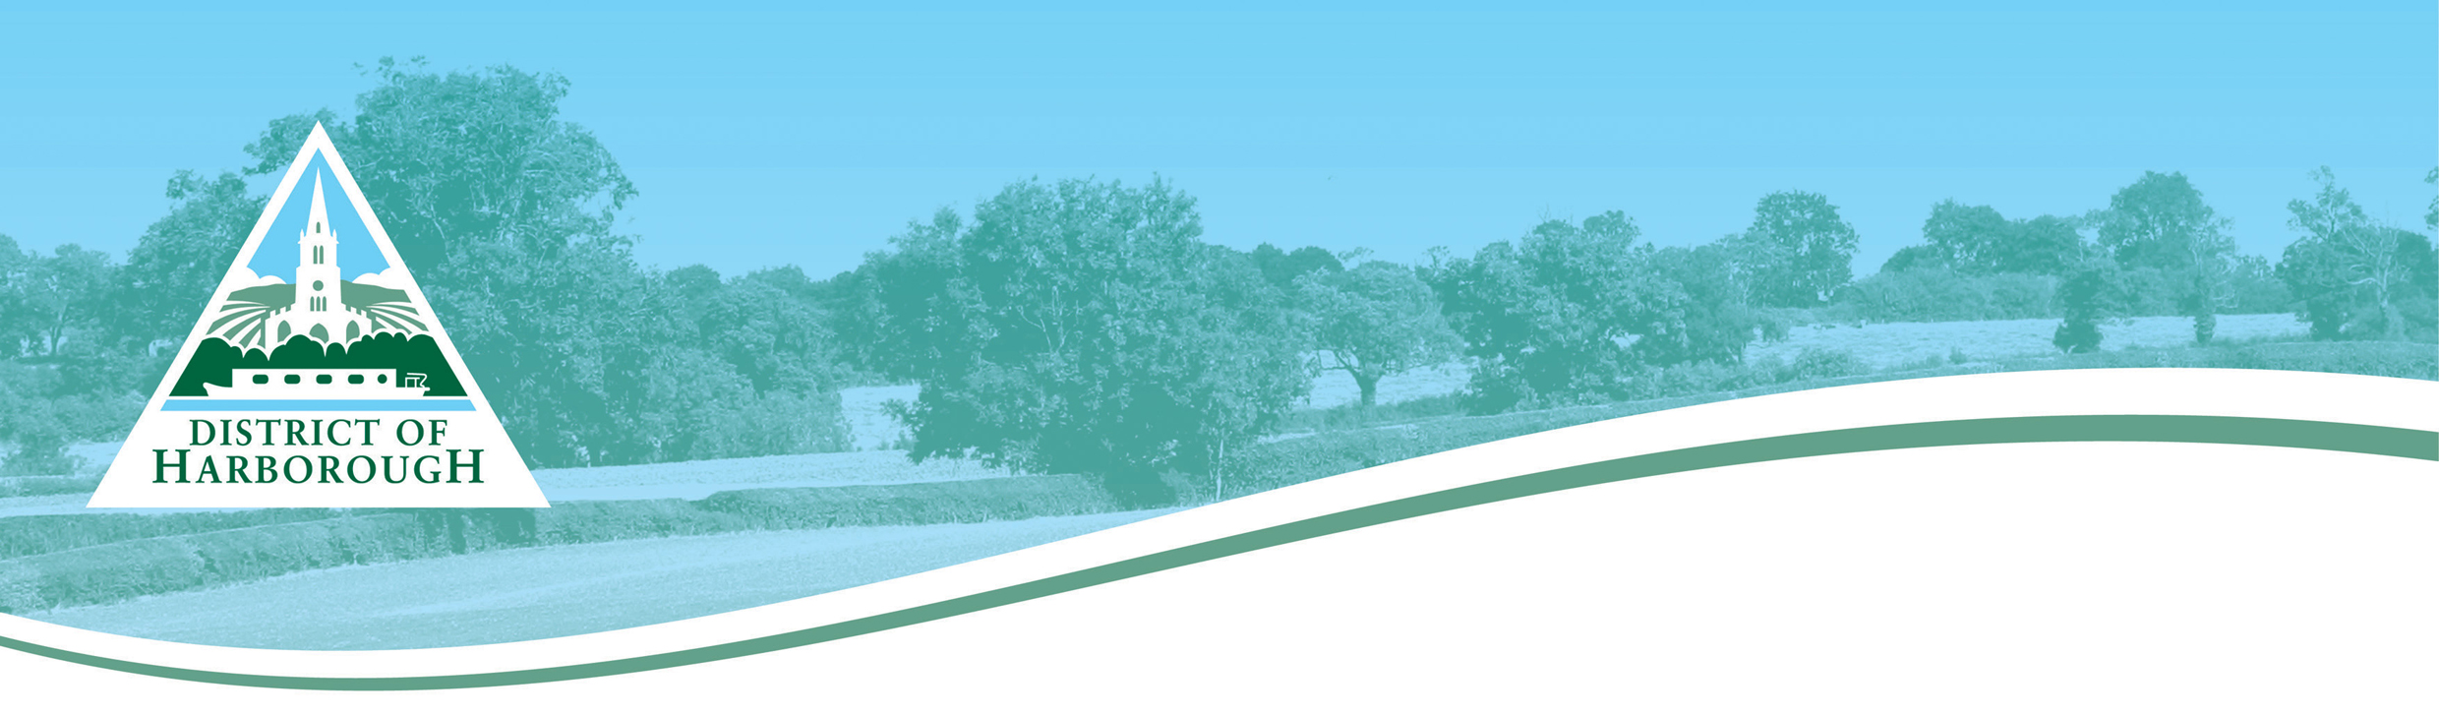
Application for new property address.
Developments up to 5 properties, multi-occupancy buildings, conversions.

1. Applicant Details

Name of contact
Company name
Contact address

Telephone number - Land
Telephone number – Mobile
Fax number
Email address

How would you prefer to be contacted?

2. Application Details
Application for:-

Current Full Property Address
Please provide Planning Approval Ref.
or a developers site plan

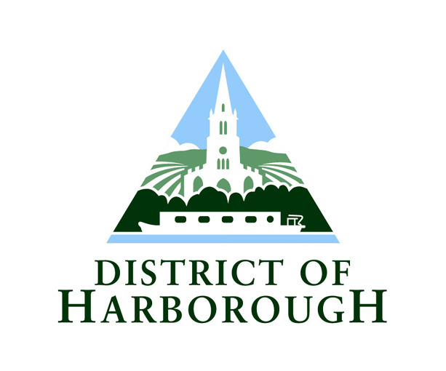
Where ever possible, new properties will be numbered off the existing road, in sequence to existing numbering. In such cases where this is not practicable, a property name or sub-street name will be considered. If you wish for any property names to be considered, please include these below.

New Address Requested.
Please provide details of any names you wish to be considered.
Please refer to the SNN Guide - the Council
will approve names based on the protocol
outlined in the Guide.

3. Declaration
By signing/ticking the box below and submitting this application to the Council you are confirming that you are the legal owner of the property/development/land and as such have the right to make the application.
Tick this box, save the completed form and submit by email.

Or:
Name | Signature | Date
Print this form and sign and post.

4. Further Information
Please refer to the website/contact the Street Naming and Numbering Officer for current information on fees and charges

5. Next Step
Save this form and submit by email, or print and return via the post or fax. The Street Naming and Numbering Officer will now check that the new name is acceptable. If it is, the Council will then forward the chage/addition to the Royal Mail. If the name is not acceptable you will be contacted to review your choice.
All postal addresses are allocated in accordance with BS7666.

If you are a developer and do not wish to allocate names, please contact the Street Naming and Numbering Officer as soon as possible, so that the next step in the process can be started. The Council will then contact either the Parish Council or a relevant Ward Member to decide upon an appropriate name.

Contacts:
Street Naming and Numbering
Corporate Services
Council Offices
Adam and Eve Street
Market Harborough
Leics LE16 7AG

Tel: 01858 821336
Email: snn@harborough.gov.uk

