# Willoughby Waterleys OSSR sites, LGS sites and Wildlife Sites Note the LGS sites are proposals only at Sept 2015

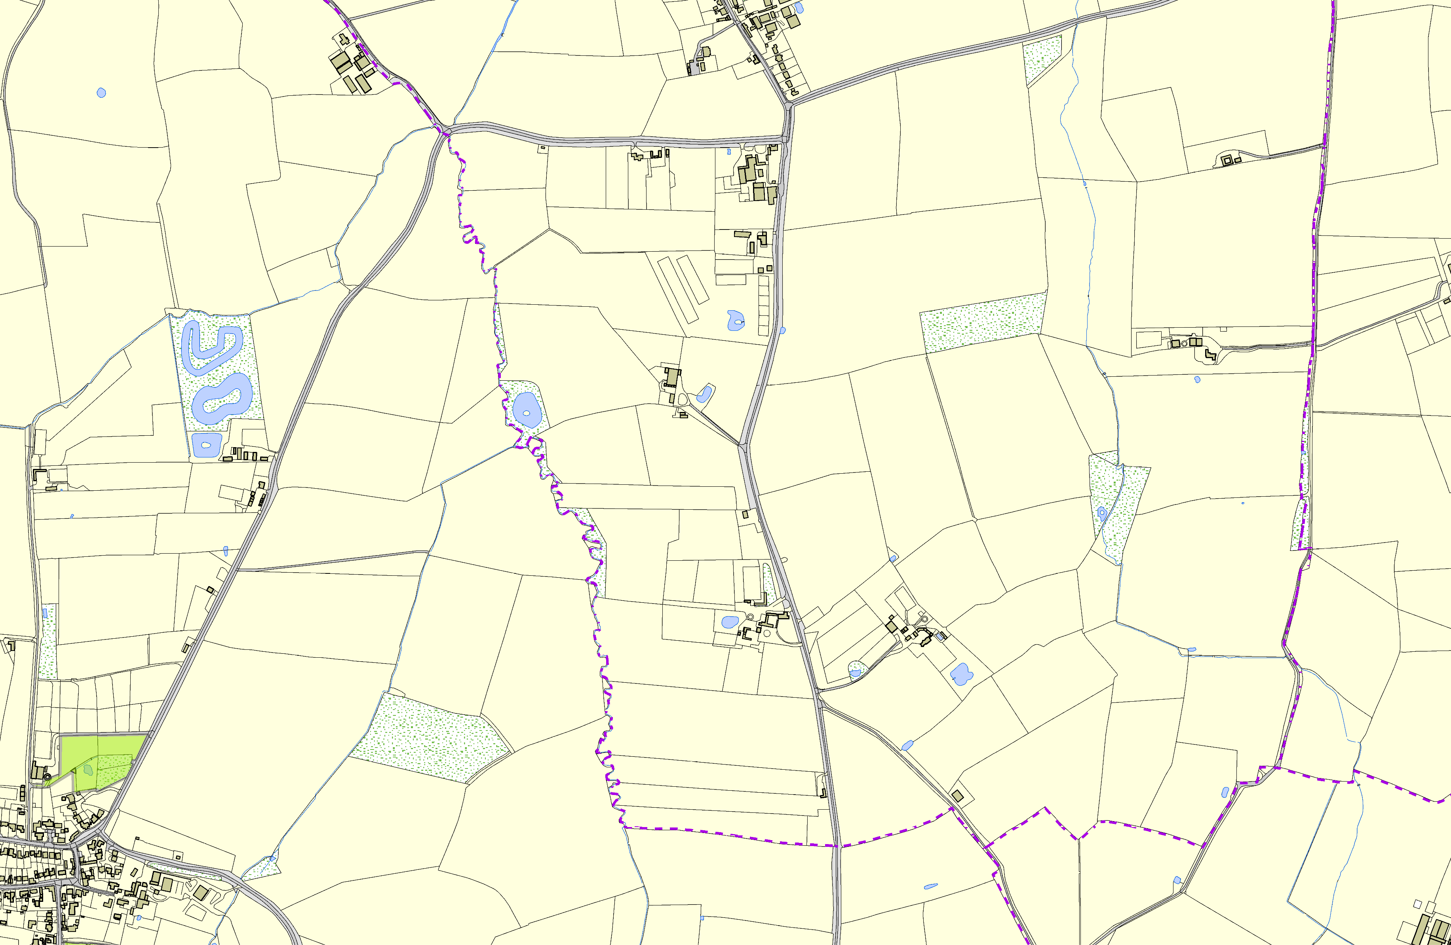

**Legend**

Not recommended for LGS Designation Recommended for LGS designation Wildlife Sites

Open Space, Sport and Recreation Sites

# OS MM Boundary

**DESCTERM**

!!!!!!!!!!!!!!!!!!!! County

District Electoral Parish

Ashby Magna Open Space

St Mary's Church - Ashby Magna

**©Crown Copyright. All rights reserved. Harborough District Council 100023843 2014**