# Willoughby Waterleys OSSR sites, LGS sites and Wildlife Sites Note the LGS sites are proposals only at Sept 2015

Fishing Lakes - Willoughby

Willoughby Waterleys Pond 2

St Mary's Churchyard - Willoughby

St Mary's Churchyard - Willoughby Village Hall and Playground - Willoughby

Cemetery - Willoughby

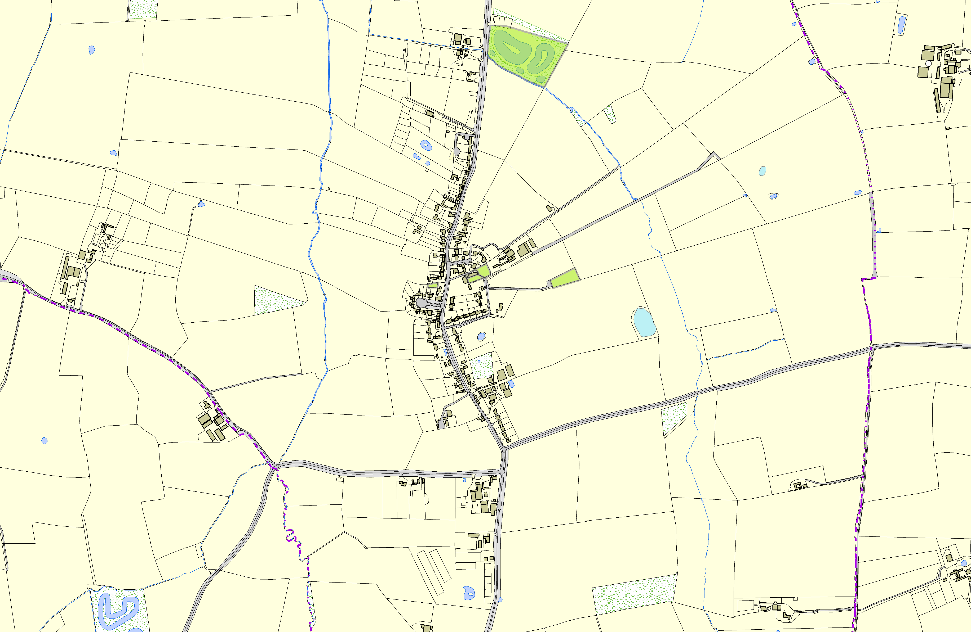

Willoughby Waterleys Lake Fishing Pond - Willoughby

**Legend**

## Not recommended for LGS Designation Recommended for LGS designation Wildlife Sites

Open Space, Sport and Recreation Sites

**OS MM Boundary**

**DESCTERM**

!!!!!!!!!!!!!!!!!!!! County

## District Electoral Parish

**©Crown Copyright. All rights reserved. Harborough District Council 100023843 2014**