Nevill Holt OSSR sites, LGS sites and Wildlife Sites Note the LGS sites are proposals only at Sept 2015

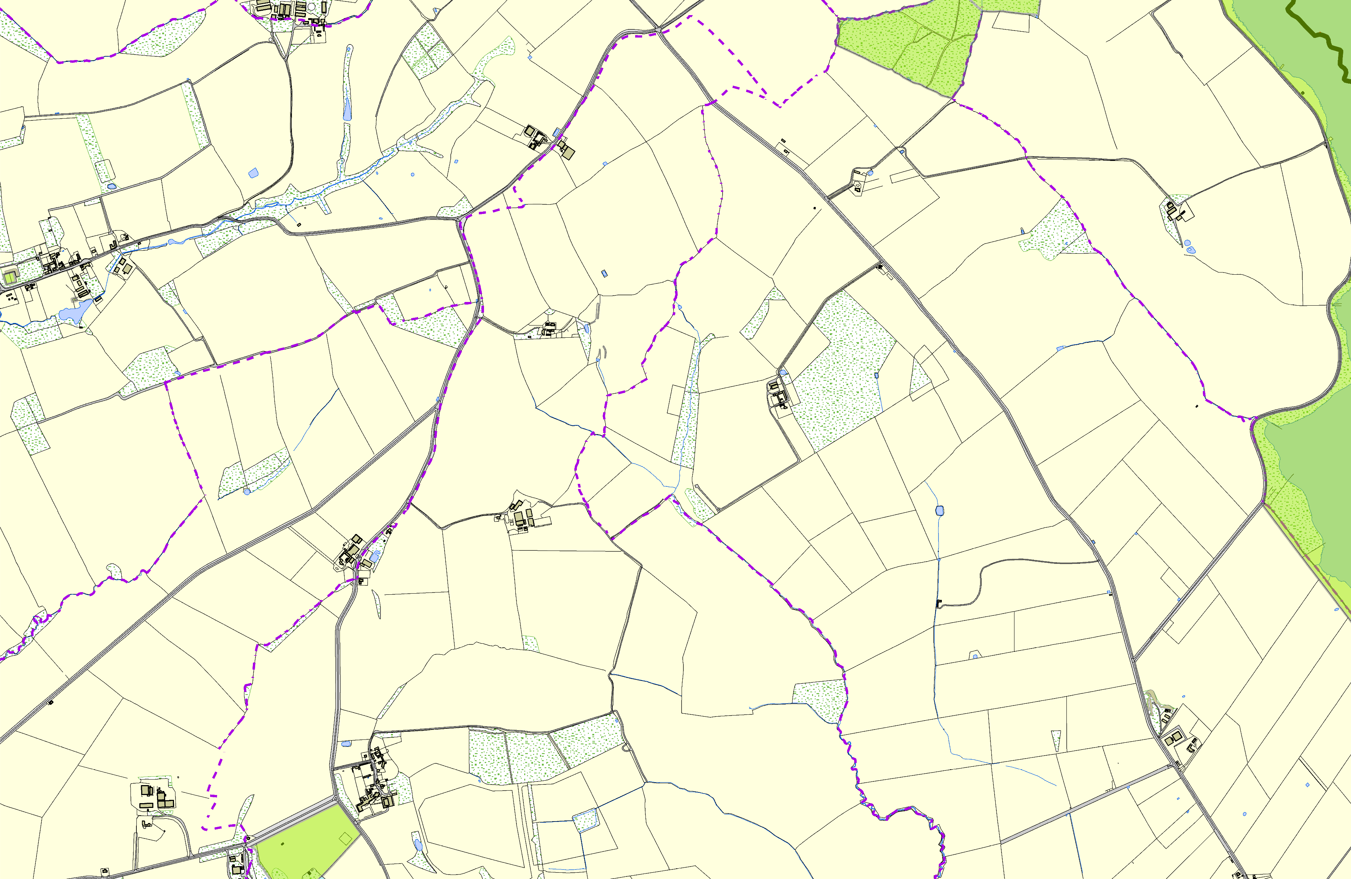

|  |  |  |  |  |
| --- | --- | --- | --- | --- |
| Blaston Tennis courts  St Michaels Redundant Churchyard - Blaston | | Nevil Holt Sports Field  Neville Holt Quarry, Neville Holt | Great Merrible Wood | Great Merrible Wood  **Legend**  Not recommended for LGS DeEsyeigbronoak Rtieosenrvoir Recommended for LGS designation Wildlife Sites  Open Space, Sport and Recreation Sites  **OS MM Boundary**  **DESCTERM**  !!!!!!!!!!!!!!!!!!!! County  District Electoral Parish  Eyebrook Reservoir |
|  | **©Crown Copyright. All rights reserved. Harborough District Council 100023843 2014** | |  | |